Example of ’Cherry pick no commit action’ creation:

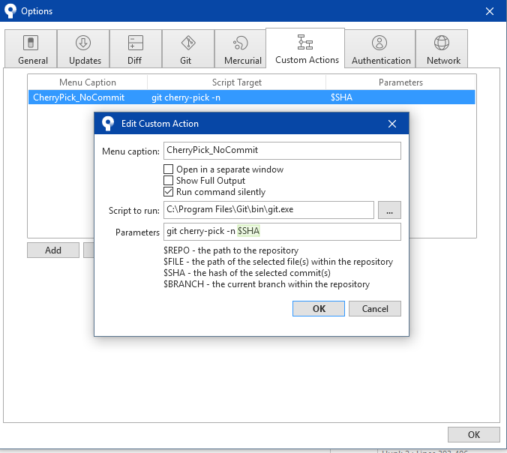

How to use: right click on commit -> Custom actions -> CherryPick_NoCommit